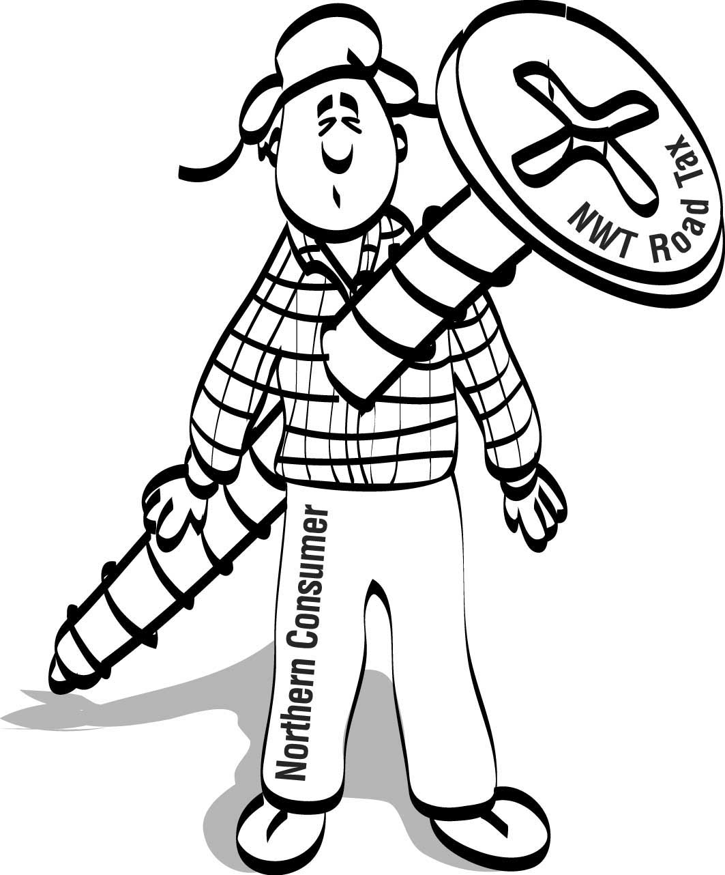

Road Tax Fax

Did you know?

1. The GNWT’s proposed Trip Permit Fee is really a Tax.

2. You, the average householder, will pay most of the burden of this Tax as an increase in the price of everyday goods. Examples of added costs because of this Tax:

Hay River Fort Smith Rae/Edzo Yellowknife
Gas (cents per litre) 0.5 1.5 1.6 2.0
Home heating fuel 0.5 1.7 1.9 2.3
New house $290 $910 $1,010 $1,250
Fishing boat $23 $73 $81 $100
Snowmobile $12 $36 $40 $50

The government’s cost figures don’t tell the whole story. Trucks cannot always run at full weight Someone has to ship the rice crispies, pampers and insulation. The government figures also don’t tell you that truckers will have to administer this Tax: an additional cost that will be passed on to consumers.

3. Communities resupplied by air will feel an even heavier burden. Aviation fuel is trucked to many centres and this Tax will cause increased airfares and freight rates to many off road communities. Municipalities, School Boards and the NWT Power Corporation will face higher costs because of this Tax. You will pay those increased costs.

4. The Cost of Living Tax Credit will not offset the effect of this Tax. The Tax Credit is based on income, not on the rise in the real cost of living. Higher income earners will be able to claim the highest Tax Credit. Low income earners will feel the result of this Tax most of all.

5. This Tax will hit exporters twice: once when they ship materials in and once when they ship product out. It will apply to mined zinc concentrate, fibreglass tanks, frozen fish and even recycled cans. Exporters deal in a competitive market and this Tax will make them unable to compete in southern markets where costs are already lower. This is not the way to build a healthy export sector.

WE ALL WANT BETTER HIGHWAYS. THIS TAX IS NOT THE WAY TO FINANCE THEM

What Can You Do?

Call or write your MLA now. Ask him or her to make the government give us the real facts about the Tax. Ask what alternatives were considered before deciding to increase taxes on all Northerners. Ask what the federal government is doing with the $4 billion it collects in fuel tax every year. Then tell your MLA to

AXE the TAX.

Brought to you by the NWT & Nunavut Chamber of Mines and a growing coalition of business and consumer groups who oppose this Tax

